23/03/21
THM 415: Finance
Midterm Exam Answer Sheet

- What does “Historical Cost” principle tell? What are the 2 exceptions to this very principle (2 Points)
Historical cost principle, one of the principles under the Generally Accepted Accounting Principles (GAAP), provides the basis for determining the dollar values the firm reports in its balance sheet. This very principle tells us that most assets and liabilities are reported in the firm’s financial statements at historical cost (i.e. at the price the firm paid to acquire them). The only exceptions to this principle are cash and assets held for sale (such as marketable securities).
- Rachid Hotel had recorded the following income statement accounts sorted in alphabetical order:
Cost of Goods Sold | $4,030,258
Interest Expenses | $847,693
Operating Expenses | $1,903,542
Sales | $7,963,251

In addition, since Rachid Hotel owns 49 % shares of Guezzal Company, it is entitled to $ 2,033,500 of dividends income from that very company. Moreover, Rachid hotel’s board of directors decided to distribute $ 225,750 as dividends to their shareholders.
The following table reveals Income Tax Rates for Corporate Income for 2020 fiscal year:

Taxable Income | Marginal Tax Rate
$ 0 – $ 100,000 | 7%
$ 100,001 - $225,000 | 9%
$ 225,001 - $ 400,000 | 11%
$ 400,001 - $ 650,000 | 13%
$ 650,001 - $ 900,000 | 15%
$ 900,001 - $ 1,100,000 | 17%
Over $ 1,100,000 | 19%

Lastly, the following table shows dividend income exclusion to avoid double taxation at corporate level.
Ownership Interest | Dividend Exclusion
Less than 15 % | 20%
15 % to 30 % | 40%
30 % to 45 % | 60%
45 % to 62 % | 72%
62 % to 80 % | 83%
More than 80 % | 100%
a) Construct Rachid Hotel Income Statement for the year ended December 31st, 2020. (2 Points)
Moreover, the following is Rachid Hotel’s comparative balance sheet as of December 31st, 2019 and December 31st, 2020:
- Construct Rachid Hotel Statement of Cash Flow for the year ended December 31st, 2020. (3 Points)
- Calculate the Quality of Earnings. Interpret your result. (1 Point)
- Quality of Earnings = (Cash Flow from Operations) / (Net Income) = 887,909 / 916,542 = 96.88 %.
Thus, in 2020, Rachid Hotel’s cash flow from operations was 96.88 % of the firm’s reported net income.
- Calculate the Capital Acquisition Ratio. Interpret your result. (1 Point)
- Capital Acquisition Ratio = (Cash Flow from Operations) / (Cash Paid for Capital Expenditures) = 887,909 / 40,323 = 2,201.99 %.
Thus, in 2020, Rachid Hotel was able to finance 2,201.99 % of its new expenditures for plant and equipment out of the firm’s operation’s cash flow.
- Based on the income statement prepared in part a), comparative balance sheet and cash flow statement prepared in part b), analyze the financial situation of Rachid Hotel for the fiscal year 2020. (3 Points)
Income Statement:
- In 2020, Rachid hotel is a profitable company as its revenues (i.e. sales) are greater than its costs.
- In 2020, Rachid Hotel’s mark-up on its cost of goods sold is 49.39 %.
- In 2020, for each dollar of revenue, Rachid Hotel is left with 25.49 cents after deducting all its operating expenses.
- In 2020, each one dollar of sales is associated with 11.51 cents of net income.
Balance Sheet:
- Rachid hotel is a highly liquid company as its net working capital is $ 1,990,928. This means that current assets can shrink by as much as $ 1,990,928 and the company would still be able to pay its current liabilities.
- In Rachid Hotel, the purchases of assets are financed 33.13 % through debt and 66.87 % through equity.
- For each one dollar of net income, 75.37 cents are retained in the business.
Statement of Cash Flow:
Cash flow from operating activities:
- Rachid Hotel has positive cash flows from operating activities.
- The primary contributors to the operating cash flows were net income and inventory.
- Other current assets, accounts payable and accrued expenses constitute cash usage.
Cash flow from investing activities:
- Rachid Hotel invested $ 40,323 in purchasing fixed assets. This is roughly 4.54 % of the total cash flow generated from operations.
Cash flow from financing activities:
- Rachid Hotel has negative cash flows from financing activities.
- All cash outflow went as payment of already declared dividends, purchase of marketable securities payment of short-term / long-term notes and common stock (paid in capital).
- The only contributor to cash inflow came from issuance common stock (par value).
- Suppose you would like to triple your investment. For this purpose, you deposited in a bank $ 15,941.55 to be compounded weekly at an interest rate of 6.03 %. Calculate the period (in years) needed to reach your objective? (1 Point)
- Interest Rate = 6.03 % / 52 ≈ 0.11596%; Present Value = - $ 15,941.55; Payment = $0; Future Value = $ 47,824.65.
Answer: Nper (0.11596%, 0, -15941.55, 47824.65) / 52 = 18.23 Years.
Therefore, it would take 18.23 years for an investment of $ 15,941.55 to triple at an annual interest rate of 6.03 % compounded weekly.
- After examining the various interest rates opportunities, you find that you can borrow from a finance company at 14.53 % compounded semi-annually, from bank A at 14.03 % compounded daily.
a) Which alternative is the most attractive? Why? (1 Point)
- Borrowing from Finance Company: Effective Annual Rate = Effect (14.53 %, 2) = 15.06 %.
- Borrowing from bank A: Effective Annual Rate = Effect (14.03 %, 365) = 15.06 %.
→ Since I am borrowing, I shall choose the offer that has the lowest Effective Annual Rate. Therefore, I shall borrow from the Finance Company (15.0578 % vs. 15.0588 %).
b) If you wanted to consider Bank B which offers continuous compounding. What is the maximum interest rate suggested by this very bank to start thinking about the offer? (1 Point)
The maximum interest rate suggested by Bank B shall be 14.03 %.
- Rosier wanted to buy a home that costs $ 300,000. He took a 5-year mortgage loan with semi-annual payments at an annual rate of 4.53 %.
a) How much will Rosier pay each period? (1 Point)
Interest = 4.53 % / 2 = 2.265 %, Period = 5 * 2 = 10; Present Value = $ 300,000; Future Value = $ 0
Answer: PMT (2.265 %, 10, 300000, 0) = - $ 33,862.70.
b) Fill in the amortization schedule. (3 Points)
Period | Amount Owed on the Principal (Beg. Period) ($) | Annuity Payment ($) | Interest Portion of the Annuity ($) | Repayment of the Principal Portion of the Annuity ($) | Outstanding Loan Balance ($)
1 | $300,000.00 | $33,862.70 | $6,795.00 | $27,067.70 | $272,932.30
2 | $272,932.30 | $33,862.70 | $6,181.92 | $27,680.78 | $245,251.52
3 | $245,251.52 | $33,862.70 | $5,554.95 | $28,307.75 | $216,943.76
4 | $216,943.76 | $33,862.70 | $4,913.78 | $28,948.92 | $187,994.84
5 | $187,994.84 | $33,862.70 | $4,258.08 | $29,604.62 | $158,390.22
6 | $158,390.22 | $33,862.70 | $3,587.54 | $30,275.16 | $128,115.06
7 | $128,115.06 | $33,862.70 | $2,901.81 | $30,960.89 | $97,154.16
8 | $97,154.16 | $33,862.70 | $2,200.54 | $31,662.16 | $65,492.00
9 | $65,492.00 | $33,862.70 | $1,483.39 | $32,379.31 | $33,112.70
10 | $33,112.70 | $33,862.70 | $750.00 | $33,112.70 | $0.00
c) Suppose that exactly after 2 years, mortgage interest rates fell to 3.53 %. If Rosier has the chance to refinance his loan at that very interest, how much would he pay (on a semi-annual basis) for the remaining 3 years of the loan? (1 Point)
Interest = 3.53 % / 2 = 1.765 %, Period = 3 * 2 = 6; Present Value = $ 187,994.84; Future Value = $ 0
Answer: PMT (1.765 %, 6, 187994.84, 0) = - $ 33,296.25.
d) If such a refinance opportunity is associated with paying a prepayment penalty fee to the bank of $ 3,000, shall Rosier refinance his loan? Why? Why not? (2 Points)
The answer to this question lies in coming up with cash flow increments by taking the difference of cash flows (for each of the remaining 3 years) between the first scenario (i.e. continuing paying $ 33,862.70) and second scenario (i.e. paying $ 3,000 as a penalty in year 0, and saving $ 566.45 for the remaining 6 six-month periods). To sum up, the following table reveals the cash flow increments from opting for the second scenario:
As can be seen from the above table, paying $ 3,000 as a pre-payment penalty but start saving $ 566.45 for the remaining 6 six-month periods (i.e. 33,862.70 – 33,296.25) would yield a positive return. Hence, Rosier shall re-finance the mortgage loan since he will be better off in the second scenario.
- Upon evaluation of the distribution of returns of Tosun company, the following possible rate of returns for the upcoming period as long as their probability of occurrence are estimated:
Probability of Occurrence | Rate of Return on Investment
10% | -8.53%
12% | -7.04%
15% | -2.23%
19% | 1.54%
22% | 5.87%
14% | 9.62%
8% | 12.04%
a) Calculate the Expected Rate of Return of Tosun Company stock. (1 Point)
- Expected Rate of Return = (10 % * - 8.53 %) + (12 % * - 7.04 %) + (15 % * - 2.23 %) + (19 % * 1.54 %) + (22 % * 5.87 %) + (14 % * 9.62 %) + (8 % * 12.04 %) = 1.86 %.
b) What is the risk of the investment in Tosun Company stock as measured using the standard deviation of possible future rates of return? (2 Points)
- Ersin bought some stocks of Destanoğlu Company worth of 1,250,000 Euros 8 years ago. Following is the beginning value of Destanoğlu bought stocks 8 years ago as well as the values at the end of each year up until today (the end of year 8):
Year | Annual Rate of Return | Stock Value (Euros)
0 |  | 1,525,000.00
1 | -5.63% | 1,439,142.50
2 | -2.74% | 1,399,710.00
3 | 4.14% | 1,457,657.99
4 | 6.23% | 1,548,470.08
5 | 2.02% | 1,579,749.18
6 | 7.37% | 1,696,176.69
7 | 8.69% | 1,843,574.45
8 | -2.25% | 1,802,094.02
a) What will be the annual rate of return that Ersin expects to earn next year, if he plans to continue holding Destanoğlu Company stocks? (1 Point)
- Annual rate of return that Ersin expects to earn next year, if he plans to continue holding Destanoğlu Company stocks = (- 5.63 % - 2.74 % + 4.14 % + 6.23 % + 2.02 % + 7.37 % + 8.69 % - 2.25 %) / 8 = 2.23 %.
b) What annual rate of return that Ersin expects over a five-year horizon from holding Destanoğlu Company stocks? (1 Point)
- Annual rate of return that Ersin expects over a five-year horizon from holding Destanoğlu Company stocks = ((1 + 6.23%) * (1 + 2.02%) * (1 + 7.37%) * (1 + 8.69%) * (1 - 2.25%))^^{(1/5)} – 1 = 4.33%.
- You own a portfolio consisting of the following stocks:
Stock | Portfolio Allocation | Beta | Expected Return
1 | 12.00% | 0.84 | 15.00%
2 | 23.00% | 1.42 | 21.50%
3 | 18.00% | 1.35 | 17.03%
4 | 25.00% | 0.65 | 14.25%
5 | 22.00% | 1.26 | 15.75%
Assume the risk-free rate is 5.01 % and the expected return on the market portfolio is 14.28 %.
- Calculate the expected return of your portfolio. (0.50 Points)
- Expected return (Portfolio) = (12 % * 15 %) + (23 % * 21.50 %) + (18% * 17.03 %) + (25 % * 14.25 %) + (22 % * 15.75 %) = 16.84 %.
- Calculate the portfolio beta. (0.50 Points)
- Beta (Portfolio) = (12 % * 0.84) + (23 % * 1.42) + (18% * 1.35) + (25 % * 0.65) + (22 % * 1.26) = 1.11.
- Plot the security market line on a graph. (2 Points)
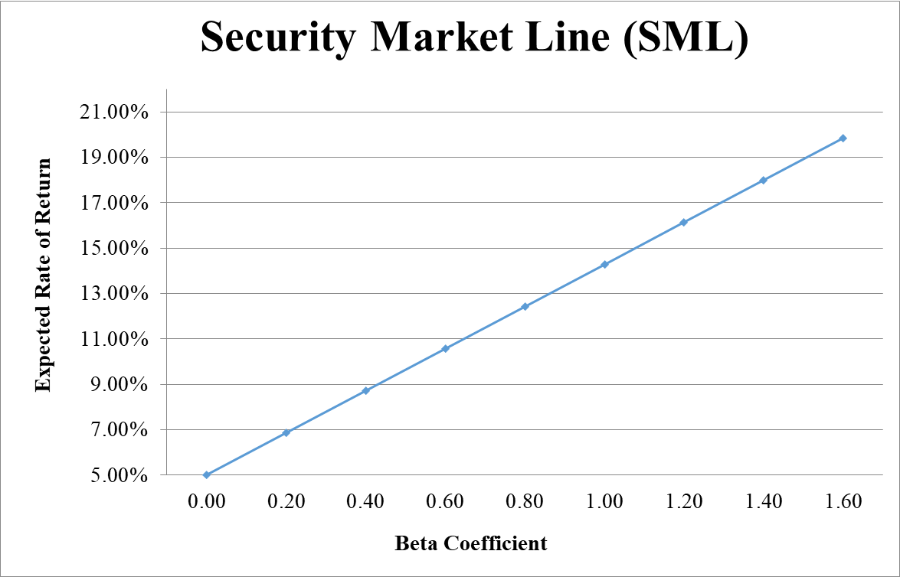
- From your plot in part c, which stocks appear to be your winners, and which ones appear to be losers? Explain the reason behind your conclusion. (2 Points)
Therefore, except stocks 3 & 5, all the other stocks are offering higher expected returns than they should be, given their systematic risks. Thus, except stocks 3 & 5, they are all underpriced. That’s why our portfolio’s expected return was higher than what was justified, given its beta.
- Why should you consider your conclusion in part d) to be less than certain? (1 Point)
This conclusion is based on our having the right betas. Recall that calculation of Betas are subjective (i.e. depend on the market to be chosen, sample size, time interval chosen, definition of period…). If all of our betas understate their stock’s systematic risks, then we would be underestimating our portfolio risk.
GOOD LUCK!

